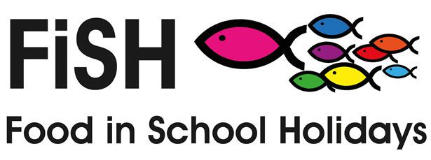
It started with a tiny seed of an idea. Some churches were providing meals in the Summer holidays for families on Free School Meals, lunch clubs with activities. I knew our church didn’t have enough volunteers for that, but I could do once a week, spuds and puds, so I did. It didn’t work very well, but we created a good atmosphere for those who came. Not a very big harvest, we didn’t reach those who needed it most and it would have died there if it hadn’t been for an approach by a lady from the Quakers.
She wanted to know more and find a way to make it work and we decided to give vouchers to families with a child on Free School Meals. We had less than 2 months to raise at least £850 from Churches Together in the Pickering area, but we raised more than twice that. We gave £20 of Co-op vouchers to the children in the Pickering Primary Schools. God had blessed the harvest.
The next step was to approach the Foodbank about their scheme in Malton, where they delivered packed lunches to families in the area. From them I got the letters they sent to schools and the application forms families on Free School Meals can reply with. That targeted the right people better and I already had contact with the schools. We agreed that in Easter and Christmas holidays, the Foodbank would deliver a weekly parcel of lunch foods and I would contact the schools and raise the money from the churches.
This worked well until the pandemic. I knew there would be need and I had the funds to help, but I had no idea how to organise food parcels and who would deliver them. I approached two District Counsellors for help, because I knew them through the volunteer network. Between us we arranged a Facebook page, a Just Giving page to raise funds and 2 very generous food parcels in the Christmas holidays to 45 families in and around Pickering, feeding 90 children whilst only spending around £400. This was with the support of local businesses and charities who donated lots of things free.
Since then, we have fed children in the Easter holidays and during the lockdowns in term time, 3 or 4 families asked for extra help. This Summer, we devised a voucher scheme with 4 businesses in Pickering and families could spend £5 per week in a Butchers, Fruit and Veg shop, bakery/café or Fish and chip shop. This gave freedom of choice to our families and made the job of providing for them much easier. We fed 20 families and over 40 children for just over £700.
I feel that, although I have tended this field, God has blessed the work and made this scheme grow from a small project that struggled to reach people in need, to a thriving enterprise where people trust us to help and approach us freely. I expect that there will be much more need in the months to come, but I trust God to continue to provide generously all that is needed for the work to be done.
We are on Facebook – search Pickering Food in School Holidays to follow our work.

