METHODISM IN PICKERING
(1764 – 2014)
_____________________________________________

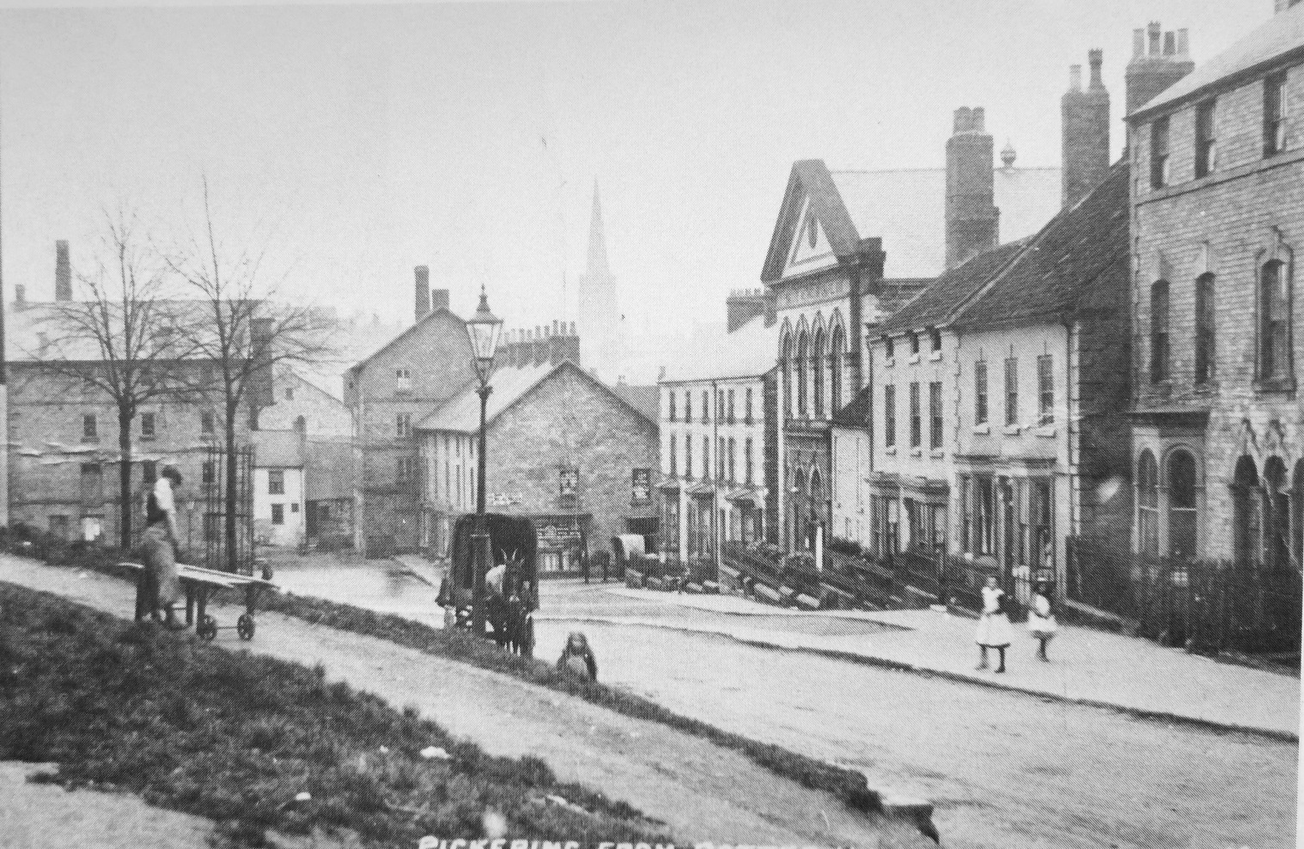
Potter Hill Primitive Methodist Church at the beginning of the 20th Century

Methodism in Pickering

(1764-2014)

A Methodist – One who takes fire, holds fire, and spreads fire ....

Rev. E A Bennett, 1935

John Wesley first came to Pickering as an itinerant preacher in April 1764 and again in 1766, preaching on both occasions in Middleton Church. He wrote in his journal on the first occasion that the clergyman there was sympathetic to Methodists, but had suffered attacks for his beliefs. On his second visit, on 16 July 1766, Wesley noted:

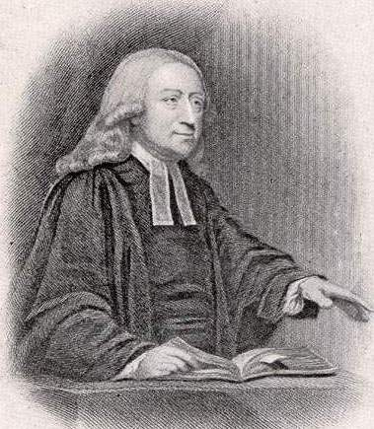
About ten I reached Middleton, near Pickering. The church was pretty well filled. I preached on part of the Second Lesson, John 4; particularly the 24th verse; and all the congregation seemed earnest to know how they might worship God “in spirit and in truth.” In the evening most of the congregation at Malton were of another kind; but a whole troop of the Oxford Blues, who stood together and were deeply serious, kept them in awe so that all behaved decently, and many of the soldiers were present again in the morning.

A Methodist society was formed in Pickering soon afterwards and a list of 1777 shows a membership list of twelve – Joseph and Mary King, John and Francis Lancaster, Hen.Foster, Hannah Harrison, Hannah Gray, Elizabeth Sheffield, Thomas Emmerson, John and Esther Richardson and Jane Dickinson. By 1788 the society numbered 39, and they decided to dedicate a small meeting house in Willowgate. When Wesley came again on Midsummer Day, 1790, he was within a week of his 88th birthday. He was passing through the town on his way from Whitby to Malton, when, according to his Journal, some members of the Society found out and called on him to speak to them. He was taken by his friend, Samuel Bradburn to Willowgate, and he notes that the preaching house was full in a few minute’s time. While still in the area a few days later, he composed a letter to the Bishop of Lincoln complaining that certain followers had been banned from preaching and he stressed to the bishop that Methodists were still members of the Church of England, that they were not a separate church and that they:

...held all her doctrines, attend her service, and partake of her sacraments. They do not willingly do harm to anyone, but do what good they can to all. To encourage each other herein they frequently spend an hour together in prayer and mutual exhortation. Permit me then to ask, Cui bono, 'For what reasonable end,' would your Lordship drive these people out of the Church. Are they not as quiet, as inoffensive, nay as pious, as any of their neighbours except perhaps here and there an hairbrained man who knows not what he is about.

After Wesley’s death, his followers formally split from the Church of England and established a separate church and this had implications in Pickering, where the Wesleyan Society, now numbering 45, built a new Chapel in Hungate in 1812, suitable to meet the needs of the circuit of which it was now the head. It fronted the street with a long graveyard behind. (The Rev. Joseph Kipling, the grandfather of Rudyard Kipling was minister there in 1837. When the poet and lay preacher, John Costillo died in 1845 he was buried there. It is also the resting place of the Rev George Piercy, a leading Wesleyan missionary, who was born in Lockton or Levisham and left his parents in 1850, at the age of 21, to travel to China as a missionary. He set up a mission for servicemen in Hong Kong and then moved to Canton in China where he carried on his missionary work for the next 30 years, before returning to London, to open a mission for Chinese seamen who frequently suffered from opium addiction. He died on July 16, 1913, at the age of 84.)

The early Pickering circuit went from strength to strength, as the church established itself. By 1848 there were two ministers and 52 local preachers on the Wesleyan Pickering Circuit Plan. The Wesleyan Society in Pickering had 80 members in 1855, when the Rev. J. Hornabrook formed a committee to consider building a day school. This was something of a venture of faith for the small community but it was approved by the Wesleyan Education Committee, which offered grants of £650 and the school was built at a total cost of £1230. Grants, bazaars, subscriptions and public collections raised the remaining money. The Wesleyan Education Committee praised the new school, whose buildings were ‘extensive, neat and useful, including a large room and classroom with galleries to accommodate 200 juveniles; a room for an infant school, with classroom and galleries to accommodate 150, and also a large room for needlework... with good play-grounds for the children.’ The society took great pride in its school and it maintained an average attendance of over 250 pupils for the rest of the century, the largest elementary school in the town. The School Account books show how much it was supported by the chapel – with frequent bazaars and public lectures held to supplement the monies from government grants and the children’s ‘school pence’. It was enlarged in 1895 to accommodate 308 children and by 1903 had a complement of 12 teachers. 1927 saw the retirement of G.G. Skelton, the headteacher of 37 years. The school was crowded during the Second World War, as it had to accommodate some 60 evacuees alongside its usual complement of 257 children. It closed and the building sold in 1978, by which time it was among the last 40 Methodist schools to survive in the country.

  - Primitive Methodism
Primitive Methodism began with an ‘All Day of Prayer’ held at Mow Cop in Staffordshire on 31 May 1807. This led, in 1811, to two groups joining together, the 'Camp Meeting Methodists' and the Clowsites led by Hugh Bourne and William Clowes. The movement was led by charismatic evangelists, whose ideas were at variance with those of Wesleyan Methodism - particularly their support for day-long, open air camp meetings involving public praying, preaching and Love Feasts. The Wesleyan leadership were attempting to establish themselves as a respectable church at this time and were fearful of the ‘enthusiasm’ and ‘ranterism’ expressed in some meetings. Wesleyans even took to wearing preaching gowns (reminiscent of clerical robes) and to conduct their own communions and baptisms. The Wesleyan Conference condemned female ministry in 1803, so effectively closed its doors to female preaching, yet this was encouraged by the Prims. The Prims’ own preachers were plainly dressed, wanting to stand out as a ‘peculiar people’, and they spoke plainly in local (Pickering) dialect, in contrast to Wesleyan services ‘embellished with literary allusions and delivered in high-flown language’. The first Primitive Methodist preacher to visit Pickering came from Hull and took his stand on a stone half way up Burgate on a market day in 1820. On 22 April 1821, the ‘Prims’ opened their first chapel, in Bridge Street, (now behind a butcher’s shop), under the Rev. Jane Ansdale, who went on to be a most successful resident minister. So great were the crowds that day, that they were estimated at nearly 5,000 (the whole of the town had turned out) with six other preachers called to speak outside to the crowds. A feature of the Primitive Methodist church at this time was the work of women as ministers and lay preachers. Ann Frank and Jane Fletcher of Hutton le Hole rode to preaching appointments on well-groomed donkeys. Ann joined them in spite of the opposition of her family and she went on to see the conversion of her brothers and her parents. They were enthusiastic instead of formal and recruited from poorer sections of society never listened to before.
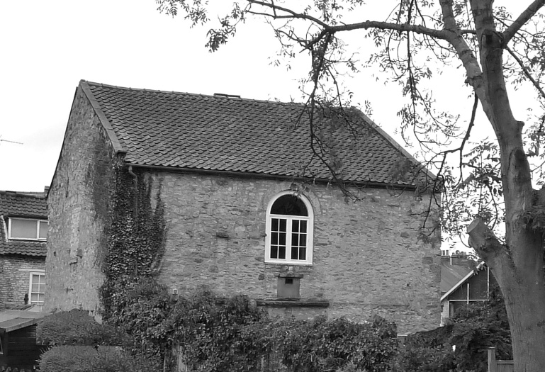
The first Pickering Primitive Chapel

The Rev. H.B. Kendall described a famous camp meeting at the town on 19 August of its founding year, 1821. This began at 9.30 in the morning with singing and prayers, followed by preaching from Hessay: ‘the praying companies, five in number, wrestled with God in the valley. Kendall describes the scene:

On one side was the ancient castle with its cloud-capt towers, the ruins of which were awfully grand. Another side presented a distant view of the town of Pickering. Another view gave the lofty quarries of limestone. On another side was a large plantation of lofty and majestic trees of different kinds. Through the valley ran a winding brook, calling to mind the lines, ‘Our time, like a stream, glides swiftly away. But at the important moment the sound of prayer and praise was heard through the valley, and five large companies pleaded with God for precious souls...When we had gone through the services of the day, we concluded the field-labours, and retired to hold a love-feast in the chapel, where, after two or three had spoken, the word of the Lord broke out on every hand...

The women sang gospel songs and souls were converted. Camp meetings continued regularly at the town. There were oft-told stories of a local Primitive character, Joe Hesp, who, on a camp meeting morning, could be found at 4 a.m. praying on his knees at the minister’s house, ‘Lord, Thou seest the shepherd is sleeping while the sheep are perishing. Do thou awake him’. It was also said that the minister one day found Joe on his knees breaking stones at the roadside and asked, ‘Are the stones so hard that you have to kneel to break them?’ Joe retorted,’ If you were to spend more time on your knees, you would be more able than you are to break the hard hearts of your hearers.’ Because of his loud ‘Amens’ and loud handclapping in church, people tended to sit well away from him, with one earnest old grandmother told him to sit quiet in church with no handclapping like someone out of their head, he replied that the Bible said, ‘we hae to clap our hands and shout!’ Her response was that the Bible also told people to pay their debts first, then shout praises to the Lord after (which clearly he did not do!)

The national religious census which took place on Sunday 30th March 1851 showed a third of the population attending church on the census day, and, in Pickering, overall attendance revealed 35.3% attending the Church of England, 32.6% the Wesleyan chapel, and 26.4% the Primitive Methodist Chapel, (with a very small Roman Catholic presence.)
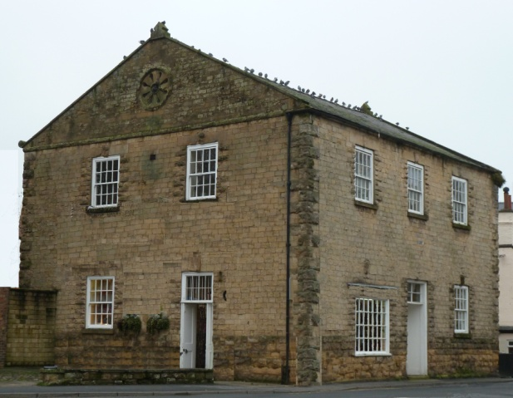
Pickering’s Second Primitive Chapel
In 1851, under the ministry of Rev. John Jobling, a new Prim chapel was built on Bridge Street to accommodate the larger congregations. It was sited almost opposite to the last one and for a time the society used both buildings. The Prims had 129 members by the time, out of a total population in the town of 2,511 people, with many other worshippers not in full membership. The chapel accommodated 580, with 400 rented pews and 180 free seats. In the evening, it was said these were virtually all filled. Church membership was demanding, and a note exists of a week of missionary ventures in 1852, which began on 31 January 1852 with a protracted prayer meeting at 5.30 a.m. each morning. This was followed by a series of marches, the singers meeting on Eastgate at 5.30 on the Sunday evening of 1 February and processing in song to chapel; on the next evening at 6.45p.m., they processed from Westgate, and on the following days from Burgate and Bake House Lane. On the fifth evening, a Thursday, they again processed from Eastgate, and on the Friday evening again from Westgate to the chapel, thereby covering the whole town with prayer and praise. There was a strong revival in the 1860s, bringing a lot of young men into membership. The peak of its influence was in the 1880s, and in 1884-5 a new chapel, the third was built in Italianate style, on Potter Hill for £3,400, to hold 600 people, with a Sunday school of 400. The old chapel in Bridge Street was sold to the Railway Company for £1700.
At the time the Pickering circuit was in the Leeds and York district, where Thomas Howdill (1840- 1918) was a renowned chapel architect and he was given the commission to build the new chapel. There had been calls to make him the architect for the whole of the Methodist Connexion, but many of the districts objected, wanting to maintain their independence. Thomas was born in Tadcaster where he became a local preacher and joiner. Then in 1863 he moved to Leeds and became a member of Rehoboth Chapel. Joseph Wright (1818-1865) a leading architect who had earlier worked on Leeds Town Hall in the 1850s was worshipping at the same chapel at the time and was probably responsible for Howdill becoming an architect in 1874 and he went on to design dozens of churches. The new Pickering chapel was opened on 23 June 1885, with Rev. J. P. Bellingham preaching at the opening ceremony, and the interior showed Wright's influence. One wonders if the two leading architects conferred on the designs. The trefoil, bow fronted pulpit, supported on iron pillars and with decorative ironwork, was similar not just to Rehoboth but also to Wright's Jubilee Springbank Chapel in Hull. The Pickering pulpit is virtually identical to one long ago demolished at Quarry Hill, Ebenezer in Leeds. The proscenium arch design for the Pickering organ loft is a signature design for Howdill. Nicholas Pevsner, the architectural historian who thoroughly disliked nonconformist chapels, did admit that he found that the facade continued to grow on him. His view was that the chapel interior with it curved pews was an increasingly scarce survivor even by the 1960s.

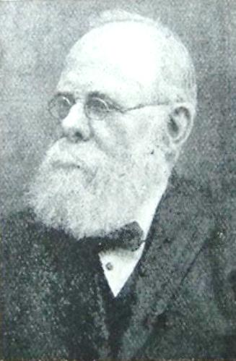
Thomas Howdill, the renowned architect of the new chapel
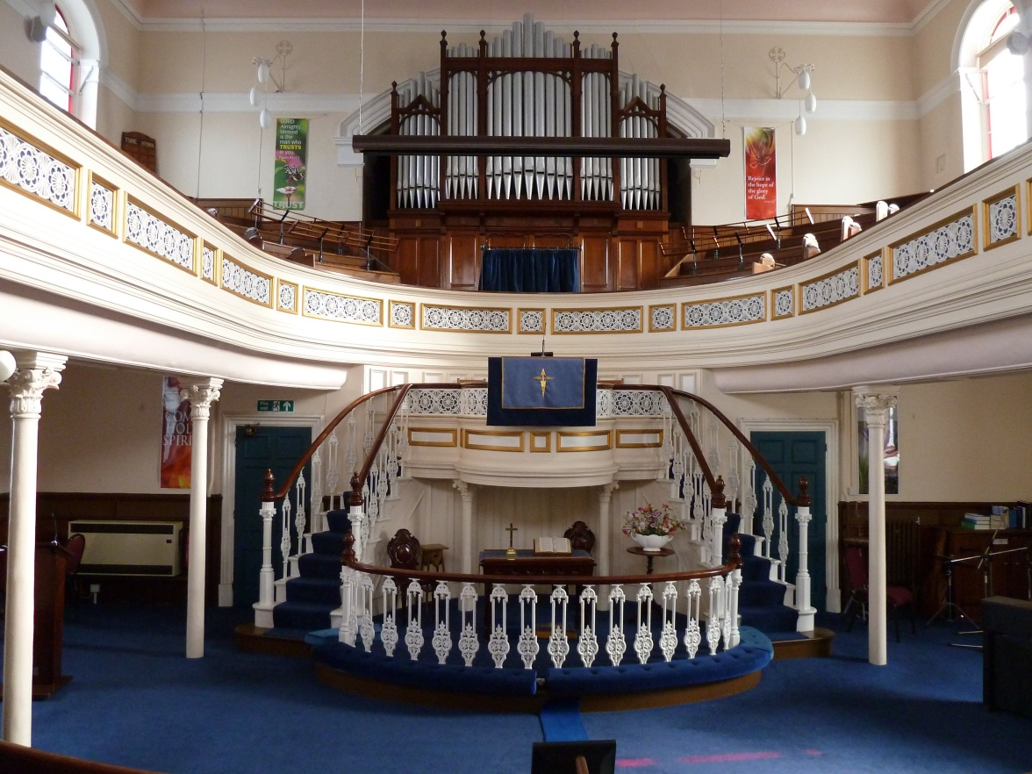
The trefoil, bow fronted pulpit, supported on iron pillars with decorative ironwork

The Rev. William Fidoe later recalled services at Potter Hill in the early 1890s, ‘the beautiful sanctuary, the splendid choir, the large congregations and inspiring services, made an abiding impression. The homeliness and loyalty and hospitality of the people, one cannot forget.’ The Rev. William Curry later recalled: ‘On a Sunday afternoon, the large Church full, with 300 young people present, and what singing with Robert Frank at the organ. And the Sunday night, Church again full, what a fine spirit of expectancy, it was a joy to preach. And the prayer meeting, well attended, no waiting... what a wonderful power was there.’

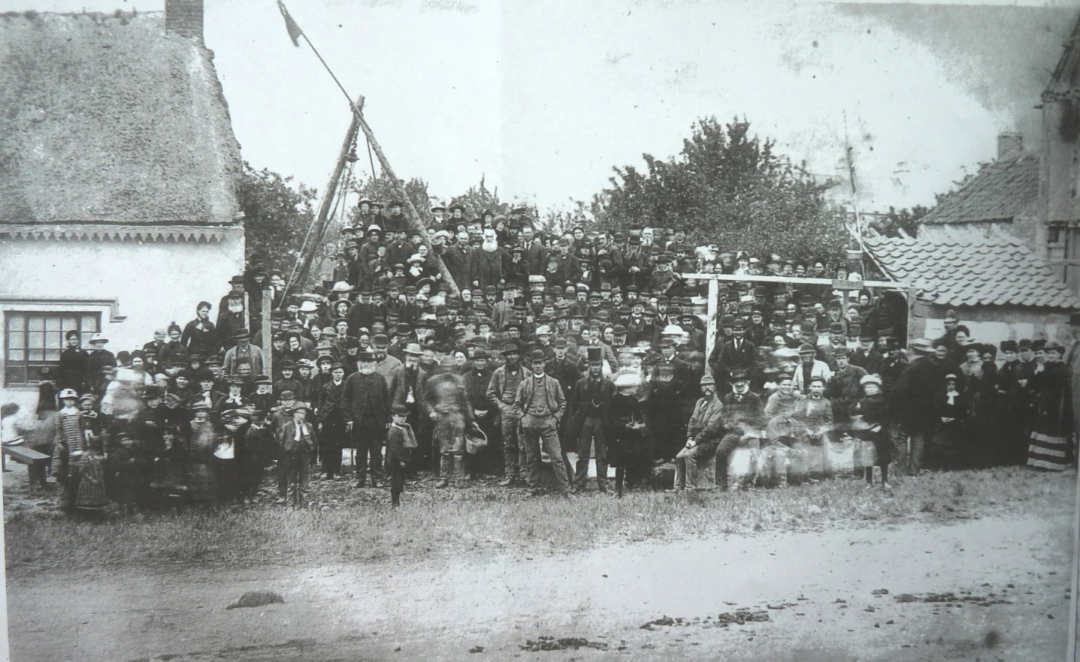

Primitive Methodist Foundation Stone Laying, 1884

Meanwhile, the old Wesleyan Chapel in Hungate, having done duty for almost 80 years, was in a dilapidated condition by 1889 and the Wesleyan congregation decided to rebuild the whole church. The old chapel was demolished in the spring and on 30 April, 1889 a ceremony was held by the Wesleyan Society to lay the foundation stones of a new, larger and more ornate edifice built in a semi-Gothic style, with an imposing front towards the street.

The chair at the ceremony was taken by Joseph Smith, a renowned preacher from Rillington, who announced:

We take part in this ceremony, having a firm conviction and persuasion that we are doing what has the approval of the great Head of the church. If I had the least misgivings on this matter, I would have taken no part in it. If by taking down the old structure for the purpose of building one larger and more beautiful, we were simply pandering to a spirit of pride and vainglory, I could not have justified my presence here...

We believe that in the chapel to be erected not only will a sound gospel be preached by a faithful ministry, but a varied and more attractive means will be used to bring the people within the sound of that gospel... we cannot but think of those who have gone, of those who worshipped and preached in the old building, of those who like angels of mercy visited the poor, the destitute, the sick, the dying; the Lord has become their everlasting light and the days of their mourning are ended. A church that amid the sorrows and darkness of this world, should guide its members to this ineffable light and fullness of joy, is worth perpetuating...

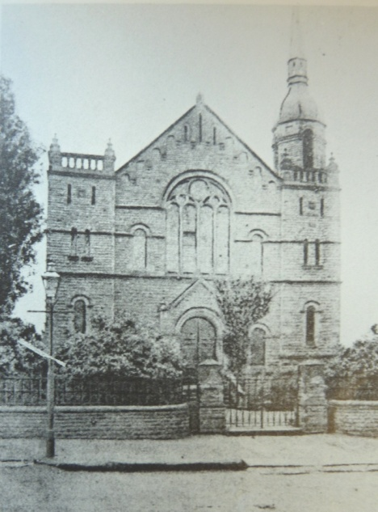

Hungate Wesleyan Chapel

A schoolroom, two classrooms, lecture room, and two ministers' houses were also included in the plan, the total cost being about £2,800. The spire was removed in the 1930s.
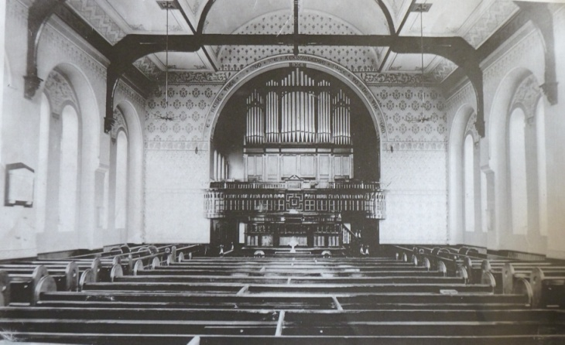

Hungate Wesleyan Chapel in 1913

(with the organ now at Potter Hill)

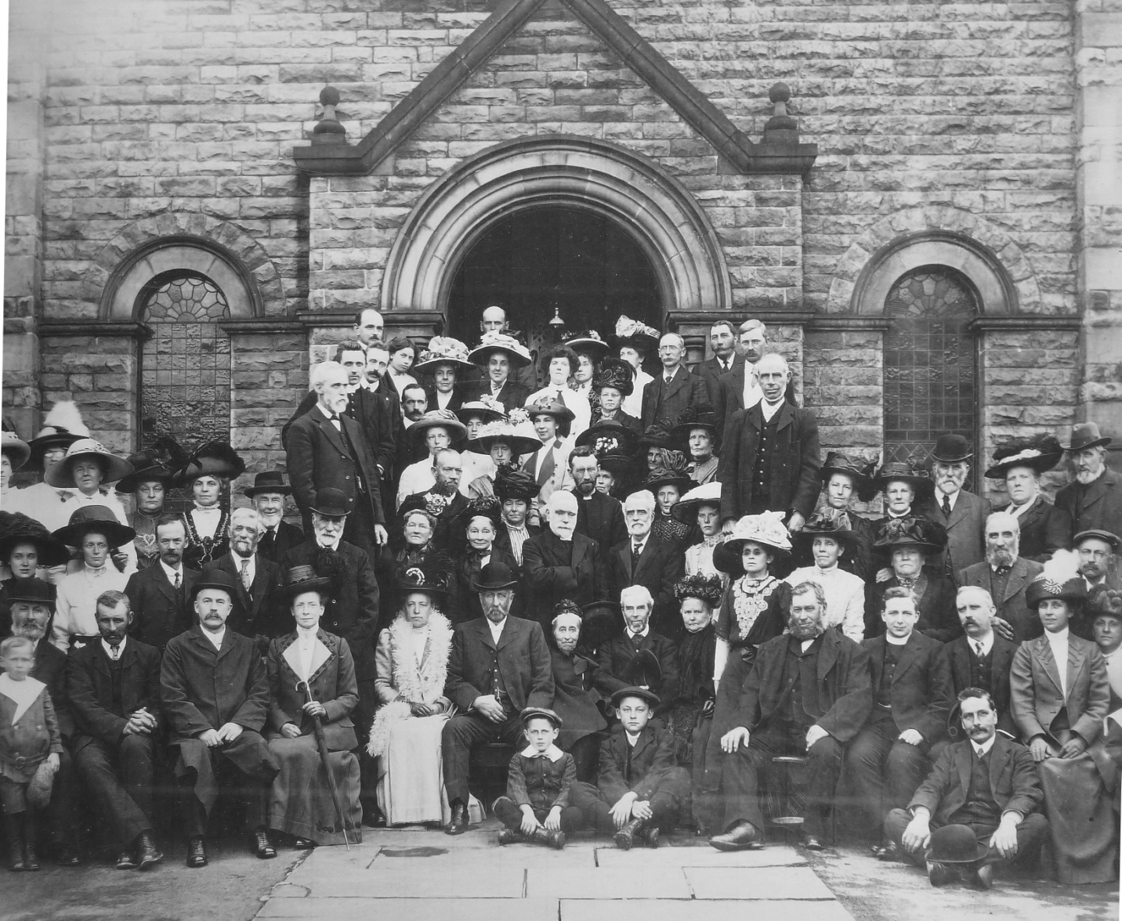

The Wesleyan Congregation in 1912

For Primitive Methodism, the 20th century brought changes to the congregation – camp meetings became infrequent. Family pews were installed. In 1910 the afternoon service was moved to the evening. It was said though that on Sunday evenings, there were no large patches of wood visible to the preacher at all. A reporter noted that in the town, the Prims were everywhere, even on the District Council.

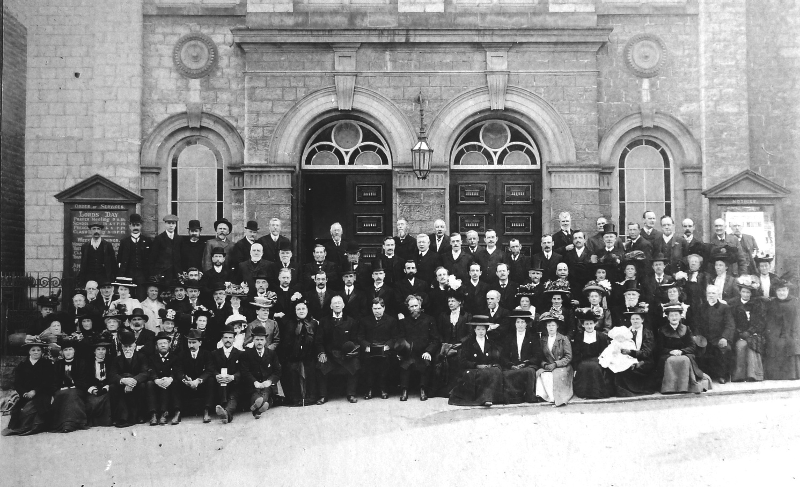

The Potter Hill Congregation in 1900

The Sunday School summer treat was usually held at Park Gates and as many as 600 were known to have gathered for tea and games. The work of running a Sunday School for 300 pupils was shared by some 60 teachers. In later years, the churches co-operated in a joint excursion to Scarborough, which even continued after the Pickering-Scarborough railway line closed in 1950 with the train going to Scarborough via Malton. The dinner and tea were prepared by teachers and Pickering was described as a ghost town, with only workmen and office workers left. Park Street would be packed with fathers at the end of the day for the return of trains. All scholars were given books at the annual Sunday School Prize Giving service, with the best books for those with the best attendance records. Bibles were given to children when they reached the age of 14.

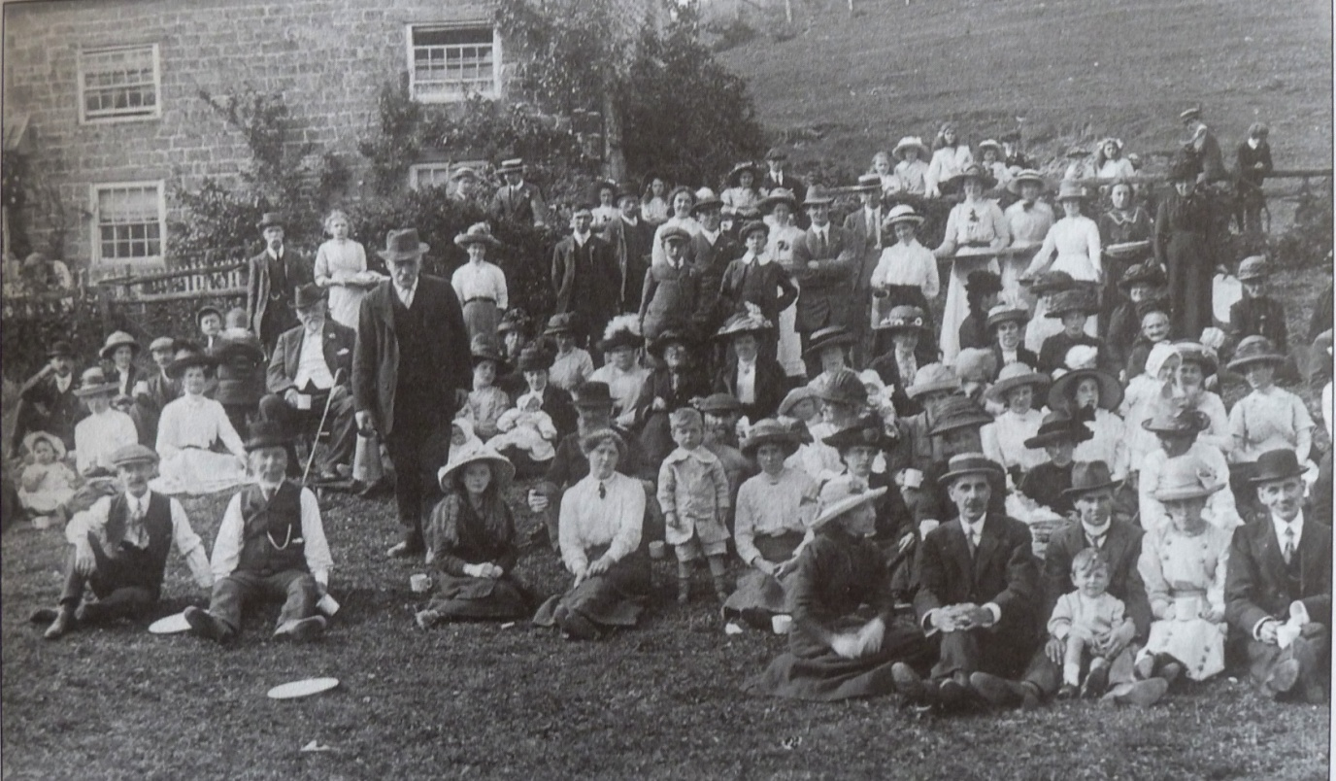

The 1913 treat at Park Fields

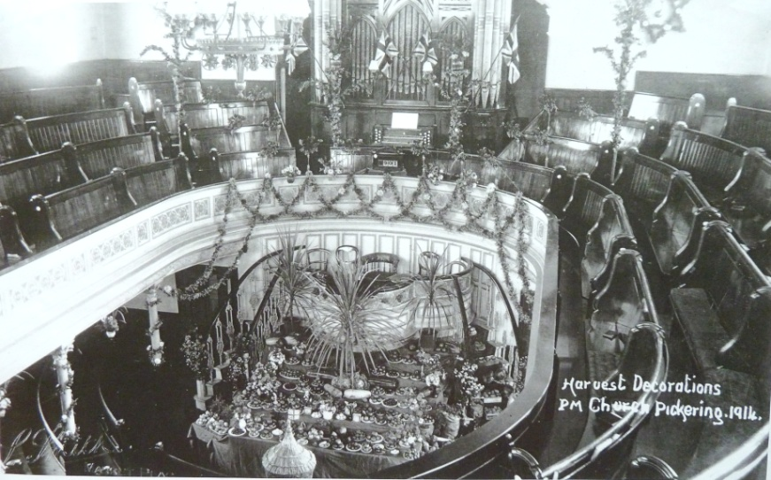

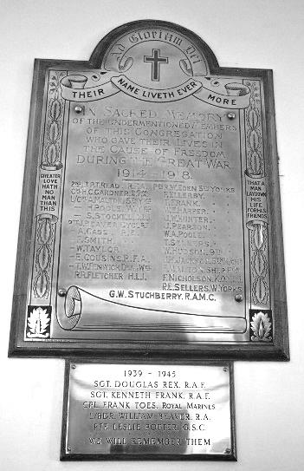
Inside the Chapel is the only memorial to the 31 Methodist servicemen who died in the two World Wars, the one in the Hungate Chapel having disappeared when it was modified into a theatre in the 1970s. The memorial is important as it does honour a number of men who are not on the Pickering Town Memorial.

A highpoint was the 1926 Primitive Methodist Synod held at Pickering, when delegates came to discuss many social problems. There were camp meetings and love-feasts, open air services and processions and a sermon was preached from the Burgate stone. 1935 saw celebrations for the centenary of the church building. Special services were held each Sunday in June with a prayer meeting at 8 a.m. Other events arranged to mark the anniversary were an old scholars’ reunion, a two day grand bazaar held in the Memorial Hall, an open-air demonstration in the market place and a visit by the Filey Fishermen’s Choir. The Rev. Herbert Semper cautioned at the Jubilee in 1935, ‘No Church can live on the glories of the past, great as they may be. As Potter Hill Church celebrates her Jubilee, may she receive new inspiration and deeper spiritual power, so that in these strenuous days, she may be a more effectual witness for her Lord and Master, Jesus Christ.’ The Rev. T. B. Caukwell, who had been minister in the circuit in 1890, wrote at the jubilee of the chapel: ‘May you who have inherited a great trust, live so as to glorify the new days by handing on to your children a yet nobler witness to the living worth of the Gospel of the Grace of God. The past and the future have their history and hope in Him who is the same yesterday, today and forever.’ The following year did indeed see a continuation of this work, with the foundation stone laid for a new Sunday school room, which included a kitchen.

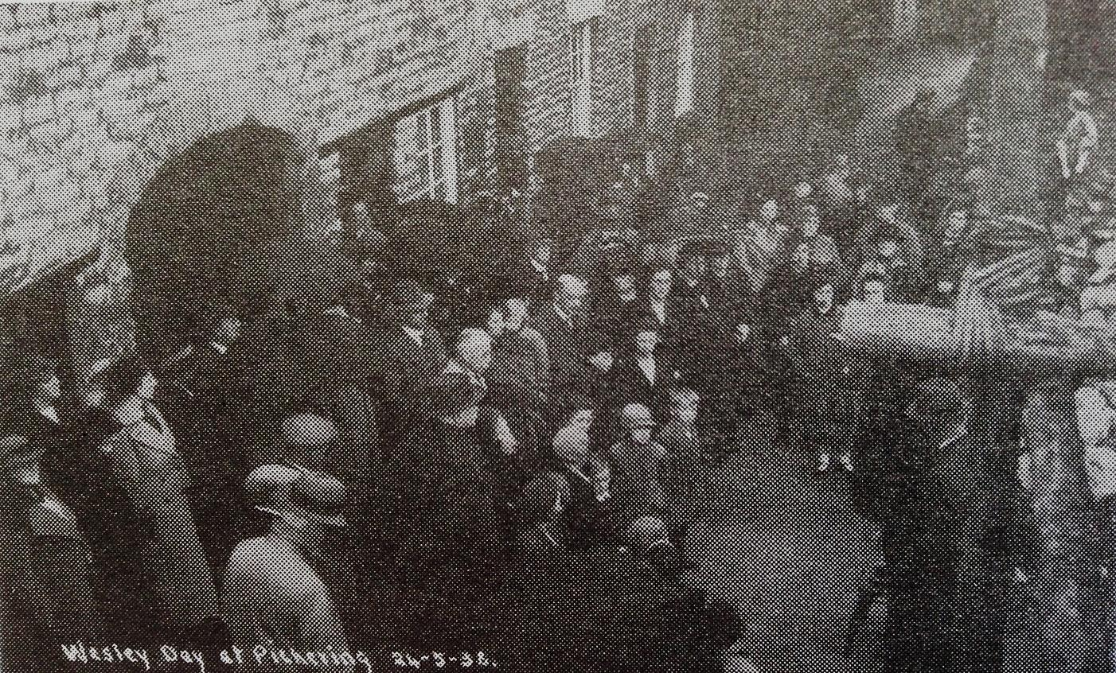

Wesley Day Celebrations at the original Willowgate Preaching House in 1938

In 1950, after much discussion, the two Pickering Methodist churches were amalgamated into one circuit. Pickering had two ministers and both chapels were kept open. (The two main branches of Methodism – Wesleyanism and Primitive Methodism – had joined together nationally in 1932.) There was though little joint fellowship. The annual Eistedfodds began in 1960, and were to continue for the next ten years, and the venue did alternate between the two churches. The 1968 Eisteddfod was reported by the press to have had 850 entries. The 1960s saw some members working towards unity with a well-attended, combined Bible Study/ Prayer Meeting which started in 1969. The two societies worshipped together from 1972. It was finally decided to amalgamate fully in 1974, with Potter Hill becoming the sole Methodist chapel in the town. Extensions were made to the back of the Chapel at this time. It was planned to sell the Hungate organ, but the organ builders advised that this was superior to the Potter Hill one and was therefore transferred to Potter Hill, although it would not fit into the original organ recess and now stands shy of the wall. It was built by James Binns of Leeds in c.1820. The sale of the Hungate building was a great loss to many traditional Wesleyans. It was sold to the Pickering Musical Society and is now a successful theatre. The church’s work continues with energy. Among its many activities are a monthly family and a ‘teen’ cinema, an Urban Saints group, a ‘Rock-it’ youth group and a monthly ‘Potters’ meeting for younger children and their parents/carers. Home groups began in 1988 and are still going strong.

There is a Monday ‘Drop-in’ and the local food bank use the premises. The Church acts as host for local groups such as playgroup, Guides, Brownies, choir and others. There is an ecumenical, ‘Open-the-Book’ team which visits local primary schools to teach local children the Bible message in an engaging and dramatic style. There is a Christmas lunch for those living alone, children’s holiday clubs, an ‘Alpha Course’ to explore matters of faith and a developing Men’s Ministry. There is the longstanding blessing of flower distributions, which began in the 1970s and still continues. Methodism then continues to be a witness to Pickering of Christ’s saving grace, 250 years after John Wesley first preached the message here on 18 April 1764.

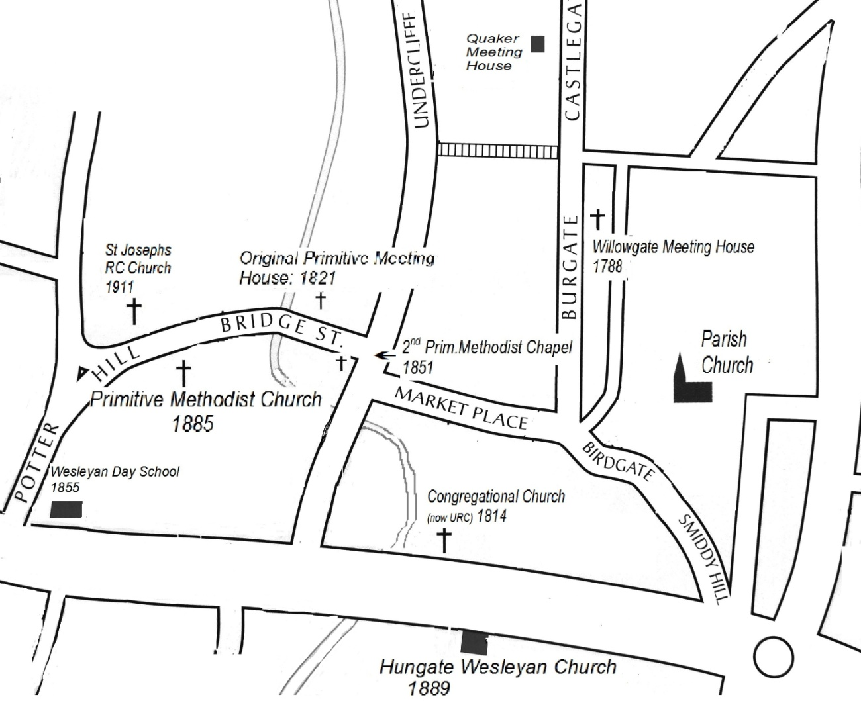

Map of places mentioned in the text

John Smith, 2014

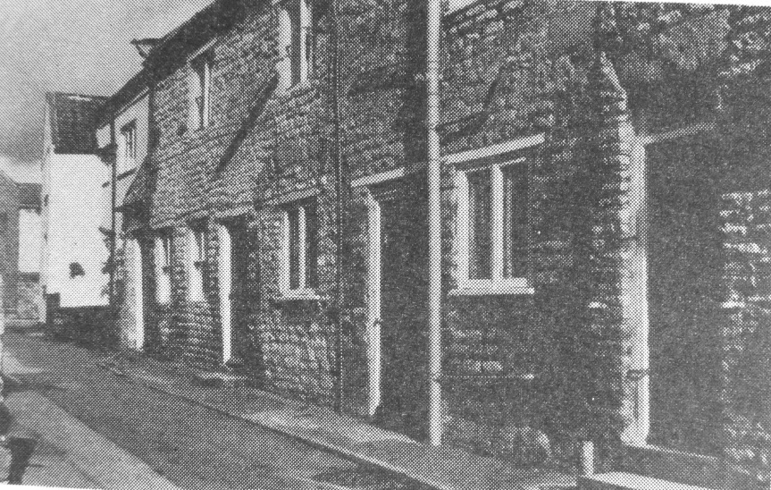

The House on Willowgate where it all began

